**Project ETAV Summary**

**Extract**

1. To start, I went to Kaggle.com and chose the dataset called *Crossfit Athletes*. <https://www.kaggle.com/datasets/ulrikthygepedersen/crossfit-athletes>

**Transform**

I created a folder to start my project with the csv file inside it, then imported the libraries I would be using, such as numpy, panda, and pyplot. I started the process of creating code cells, each cell performing a specific task.

* One for imports

* One for reading the csv file

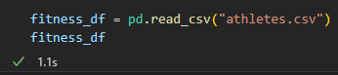

* And one for each Dataset to be created and observed from the initial finess_df dataset. This allows for each category.

**Analyze**

Some of the data in the csv seems to be entered incorrectly, however, with some research we should be able to get a more accurate view of the data.

Some of the maximum limits were set by researching world records, since bad data is often outliers laying way beyond this.

It is also important to keep in mind that when data is collected there may be biases due to circumstances.